An Advanced Deep Learning Approach for Dietary Recommendations using ROBERTA

4th Atluri Sreelaasya   
*Department of Computer Science and Engineering*  
*Lakireddy Bali Reddy College of Engineering (Autonomous)*Mylavaram, India  
atlurilaasya@gmail.com

1st Bajjuri Usha Rani   
*Department of Computer Science and Engineering*  
*Lakireddy Bali Reddy College of Engineering (Autonomous)*Mylavaram, India  
bajjuri.usharani2022@gmail.com

3rd Betha Srikanth Reddy   
*Department of Computer Science and Engineering*  
*Lakireddy Bali Reddy College of Engineering (Autonomous)*Mylavaram, India  
srikanthbetha1103@gmail.com

2nd Terli Joshnavalli   
*Department of Computer Science and Engineering*  
*Lakireddy Bali Reddy College of Engineering (Autonomous)*Mylavaram, India  
 joshnavalli176@gmail.com

***Abstract—*This project introduces a novel Food Recommendation System empowered by the Roberta model, a state-of-the-art transformer-based architecture in natural language processing. Leveraging Roberta’s advanced language understanding capabilities, our system aims to revolutionize the domain of dietary recommendations by providing personalized and context-aware suggestions to users. The Roberta model plays a pivotal role in capturing intricate textual nuances related to nutritional content, dietary preferences, and individual health profiles, thereby enhancing the accuracy and relevance of the recommendations. The methodology involves the integration of Roberta into the recommendation system, detailing the fine-tuning process and adaptation of the model to the unique challenges posed by dietary recommendation tasks. We explore the incorporation of relevant nutritional databases, ensuring that the Roberta model is well-versed in the domain-specific knowledge required for effective food suggestions. The system's performance is evaluated through various metrics, showcasing its ability to outperform traditional rule-based and machine learning-based approaches in providing tailored dietary advice. Furthermore, this project presents insightful curves and analyses derived from the model's training process, illustrating the learning trajectory, and highlighting key milestones in its proficiency. The experimental results demonstrate the system's effectiveness in adapting to diverse user preferences and evolving dietary trends, establishing its potential to positively impact users' health and well-being. Ultimately, our Food Recommendation System, driven by the Roberta model, signifies a significant advancement in the fusion of deep learning and nutritional science. The methodology curves presented herein offer a comprehensive understanding of the model's learning dynamics, emphasizing its role in revolutionizing the landscape of personalized dietary recommendations. The promising results obtained pave the way for future research and applications, underscoring the potential of advanced language models in enhancing the precision and efficacy of food recommendation systems.**

**Keywords: Deep learning, Dietary Recommendation, Natural Language Processing, ROBERTA, Transformers.**

# Introduction

In recent years, the advent of technology has spurred innovative solutions to address the ever-growing demand for personalized and context-aware dietary recommendations. Among these advancements, Food Recommendation Systems have emerged as invaluable tools, leveraging

machine learning algorithms and natural language processing techniques to provide tailored advice to users based on their nutritional needs, dietary preferences, and health objectives.

This introduction serves to explore the landscape of Food Recommendation Systems, focusing on their significance in guiding individuals towards healthier eating habits and improved well-being. While traditional approaches to dietary recommendations have often relied on generalized guidelines or manual assessments, modern systems harness the power of data-driven insights and computational models to deliver highly personalized suggestions. Key components of Food Recommendation Systems include the integration of extensive food databases, nutritional knowledge bases, and sophisticated algorithms capable of analyzing vast amounts of user data [12]. Through the analysis of factors such as dietary restrictions, culinary preferences, nutritional requirements, and health goals, these systems strive to offer recommendations that are not only relevant but also adaptable to the individual needs of each user.

In machine learning, food recommendation systems utilize various techniques to suggest personalized food options to users [6]. A popular method is collaborative filtering, which looks for patterns and similarities between users or objects by analyzing user-item interaction data. Items that are similar to those that the user has liked or rated in the past are suggested to users using user-based collaborative filtering, which bases its recommendations on the tastes of similar users. Content-based filtering is another technique employed in food recommendation systems. These methods recommend items based on the attributes or features of the items and the user's preferences. For instance, analyzing item descriptions, nutritional content, and user profiles allows these systems to generate recommendations tailored to individual tastes and dietary requirements.

Hybrid approaches offer a wider range of recommendations with higher accuracy by combining content-based and collaborative filtering techniques. By leveraging both user preferences and item attributes, hybrid methods aim to overcome limitations inherent in each individual approach, offering improved suggestions to users. Deep learning-based techniques have also gained prominence in food recommendation systems. These approaches utilize neural networks to learn complex patterns and representations from raw data, such as textual descriptions and images of food items, as well as user feedback. These models are able to offer highly customized recommendations by utilizing deep learning, which is based on an extensive comprehension of the user's dietary requirements and preferences. Natural Language Processing (NLP) plays a crucial role in understanding textual information associated with food items, user preferences, and dietary needs. Collaborative filtering and content-based filtering techniques are enhanced by NLP methodologies to extract meaningful insights from text data. In summary, NLP plays a pivotal role in enhancing the effectiveness of ML based food recommendation systems by enabling the extraction of valuable insights from textual data.

# Literature survey

Mehrdad Rostami et al. propose a groundbreaking health-aware food recommendation system that addresses the limitations of existing models by explicitly incorporating health and nutrition considerations. Their innovative approach combines time-aware collaborative filtering with a food ingredient content-based model, enabling the system to predict user preferences while prioritizing the health factor of recommended foods [1]. By leveraging datasets extracted from popular recipe websites such as Allrecipes.com and Food.com, the authors conduct thorough experimental evaluations, comparing their model's performance against several state-of-the-art recommender systems using a variety of metrics including Precision, Recall, F1 score, AUC, and NDCG. The results demonstrate the superior effectiveness of their system in generating health-aware recommendations, underscoring its potential to positively influence users' dietary habits and overall well-being [10]. This research represents a significant step forward in the evolution of food recommendation systems, offering a holistic solution that considers both user preferences and health implications, thereby contributing to the promotion of healthier eating habits in society.

Mehrdad Rostami et al. introduce an innovative approach in the food diet communication domain, recognizing the significance of images in influencing user decisions beyond traditional ingredient content. Their paper proposes an Explainable Food Recommendation system that leverages deep learning-based image clustering to justify recommendations using visual food content. By incorporating a new similarity score based on user community preferences for specific food categories, the recommendation system enhances recommendation quality. Additionally, a rule-based explainability mechanism is introduced to improve transparency and interpretability of recommendations [2]. A thorough ablation study further validates the technical soundness of the proposed recommendation system.

A new hybrid food recommender system is presented by G. Sekhar Babu et al. with the goal of addressing the drawbacks of earlier systems, including their inability to consider food ingredients, time, cold start users, cold start food items, and community factors. The proposed method consists of two phases: a food content-based recommendation phase utilizing graph clustering and a user-based recommendation phase employing a machine learning-based approach to cluster both users and food items. Furthermore, a holistic approach is integrated to account for time and user-community related issues, ultimately enhancing the recommendation quality. Experimentation with datasets extracted from "Allrecipes.com" demonstrated the superior performance of the developed food recommender-system [3]. With the rising popularity of the internet and the increasing number of web users, recommender systems are becoming more prevalent in selecting items tailored to users' needs, particularly in lifestyle applications where food recommender systems play an integral role. The hybrid approach presented in this paper not only addresses previous limitations but also considers user-based and content-based models along with time information, trust networks, and user communities to improve recommendation accuracy. Additionally, the authors suggest future works could incorporate nutritional characteristics of foods to further personalize recommendations based on individual health statuses and diseases.

Abolfazl Ajami et al. shed light on the critical relationship between proper dietary habits and overall health, emphasizing the pressing need to address the neglect of healthy eating behaviors in today's increasingly mechanized society. The paper highlights the challenges posed by the introduction of Western dietary norms and advancements in Western medicine, which have led to complexities in disease treatment and nutrition [9]. Leveraging recent advances in technology and artificial intelligence, recommender systems have emerged as a promising solution to improve people's health by offering personalized dietary recommendations. The system's efficacy is evaluated on a dataset comprising 2519 university students enrolled in a nutrition management system, incorporating factors such as basal metabolic rate, reservation records, and selected diet type [4]. By leveraging energy indicators and students' food selection histories, the system recommends food items from the university menu tailored to individual preferences and dietary requirements [14]. The study underscores the importance of considering lifestyle factors in food recommendation systems and proposes future research avenues, including the integration of temperament, traditional medicine, and deep learning methods to enhance recommendation accuracy and broaden the scope of recommendations. The findings underscore the potential of recommender systems to mitigate dietary health risks and promote healthier lifestyle choices among individuals.

R.M. Gomathi explores the pivotal role of recommendation systems in catering to personalized user needs across diverse fields, with a specific focus on restaurant selection based on individual preferences. The paper proposes a novel approach leveraging machine learning algorithms and tripadvisor.com search data to refine the recommendation process. By harnessing user comments and hotel facilities, the system utilizes Natural Language Processing (NLP) techniques to analyze sentiment and derive insights from the feedback [5]. This enables the identification of top-rated hotels tailored to user preferences, ultimately enhancing recommendation accuracy. The study underscores the significance of NLP as a powerful tool in understanding and processing human language, thereby improving the performance of recommendation systems. Through comprehensive evaluation, the proposed method demonstrates superior accuracy compared to existing algorithms, affirming its potential to deliver more precise and accessible restaurant recommendations. The findings not only contribute to advancing recommendation system technologies but also underscore the importance of integrating NLP techniques to enrich user experiences and satisfaction.

# Existing model

3.1 Content-based filtering

Content-based filtering is a method widely employed in food recommendation systems, leveraging intrinsic characteristics of food items such as ingredients, nutritional content, cuisine type, and cooking methods to tailor recommendations to individual user preferences. By creating user profiles based on dietary restrictions, preferences, and past consumption history, machine learning algorithms compare these profiles to the attributes of food items to generate personalized suggestions. This approach circumvents the "cold start" problem, offering recommendations even for new users with limited interaction history, and provides explanations for recommendations based on the features of the recommended items, fostering user trust. While content-based filtering excels in providing relevant and tailored suggestions, it may encounter challenges such as over-specialization and the inability to offer serendipitous recommendations outside established preferences [7]. Nonetheless, its ability to offer explanations and personalized recommendations based on item attributes makes it a valuable tool in enhancing user satisfaction and dining experiences in food recommendation systems. One formula commonly used in content-based filtering for food recommendation systems is the cosine similarity formula. This formula calculates the similarity between two food items based on their feature vectors, which represent the attributes of the items. Mathematically, the cosine similarity between two vectors $\overline{A}$ and $\overline{B}$ is computed as:

$$cosine_similarity(A,B)=\frac{A⋅B}{\left\|A\right\|\left\|B\right\|} (1)$$

A number between -1 and 1 is produced by this formula; a value nearer 1 denotes greater resemblance between the two food products. By calculating the cosine similarity between a user's preferences and the attributes of available food items, content-based filtering systems can recommend items that closely match the user's tastes and preferences.

3.2 Collaborative filtering

Collaborative filtering remains a versatile approach in food recommendation systems, facilitating the generation of recommendations even in scenarios where detailed item information is lacking. Its reliance on user-item interactions enables it to adapt dynamically to changing user preferences and evolving food trends. Furthermore, collaborative filtering can uncover hidden patterns and preferences that may not be evident from item attributes alone, contributing to the discovery of novel and diverse food choices. Despite its effectiveness, collaborative filtering systems must contend with challenges such as data sparsity and scalability, necessitating the development of robust algorithms and efficient computational methods [8]. Nevertheless, its ability to harness the collective wisdom of users makes collaborative filtering a valuable tool in delivering personalized and engaging dining experiences. Ongoing research efforts focus on refining collaborative filtering techniques to address these challenges and further enhance the quality and relevance of food recommendations in diverse culinary landscapes.

3.3 Hybrid filtering

Hybrid filtering stands as a potent strategy in food recommendation systems, amalgamating the strengths of content-based and collaborative filtering methods to furnish users with more accurate and personalized recommendations. By integrating the intrinsic attributes of food items with user-item interactions, hybrid filtering ensures a comprehensive understanding of user preferences and item characteristics. This approach not only addresses the limitations of individual filtering techniques but also enhances recommendation diversity and novelty, crucial for capturing users' evolving tastes and preferences [11]. Furthermore, hybrid filtering can effectively mitigate the "cold start" problem by leveraging content-based techniques to provide recommendations for new users or items with limited interaction history [13]. While challenges in algorithm complexity and data integration persist, ongoing advancements in hybrid filtering techniques promise to deliver more precise and tailored food recommendations, enriching users' dining experiences in diverse culinary landscapes and fostering engagement with food recommendation platforms.

3.4 Natural Language Processing

Natural Language Processing (NLP) plays a pivotal role in enhancing food recommendation systems by extracting valuable insights from textual data such as user reviews, recipe descriptions, and food blogs. NLP techniques enable these systems to analyze and understand human language, allowing them to interpret user preferences, sentiments, and intentions related to food choices. By processing textual data, NLP algorithms can extract relevant information such as ingredient preferences, flavor profiles, dietary restrictions, and cooking preferences, which are then used to personalize recommendations. Additionally, NLP can aid in sentiment analysis of user reviews, enabling systems to identify positive and negative sentiments associated with particular food items or restaurants. This information can further refine recommendations by considering users' past experiences and preferences. Furthermore, NLP techniques can be employed to generate descriptive and engaging content for food recommendations, improving user engagement and satisfaction [15]. Overall, the integration of NLP in food recommendation systems enhances their ability to understand and cater to individual user preferences, leading to more accurate, relevant, and personalized recommendations that enhance the overall dining experience. Moreover, NLP techniques can facilitate the extraction of key information from unstructured textual data, such as nutritional content and cooking instructions, which can enrich the recommendation process. By understanding the semantic meaning of food-related text, NLP algorithms can identify relevant contextual information, such as cultural significance or regional cuisine, to offer more contextually appropriate recommendations.

# Proposed model

4.1 Dataset

This dataset is about different types of food items along with their descriptions. It contains columns Food_ID, Name, C_Type, Veg_Non, Describe. The Food_ID column serves as a unique identifier for each food item. It is typically an integer or alphanumeric value assigned to distinguish one food item from another. Name depicts about the name of the food item. C_Type is about type of the food like healthy food, snack. Veg_Non is a binary column indicating whether the food item is vegetarian or non-vegetarian. It often takes values like "Veg" or "Non-Veg." This information can be crucial for users with dietary preferences. The Describe column contains a textual description or information about the food item. It could include details about the ingredients, preparation method, flavor profile, or any other relevant information that describes the dish. This dataset contains a total of 400 rows along with 5 columns. In these 5 columns 1 is int64 column and the remaining 4 are object columns.

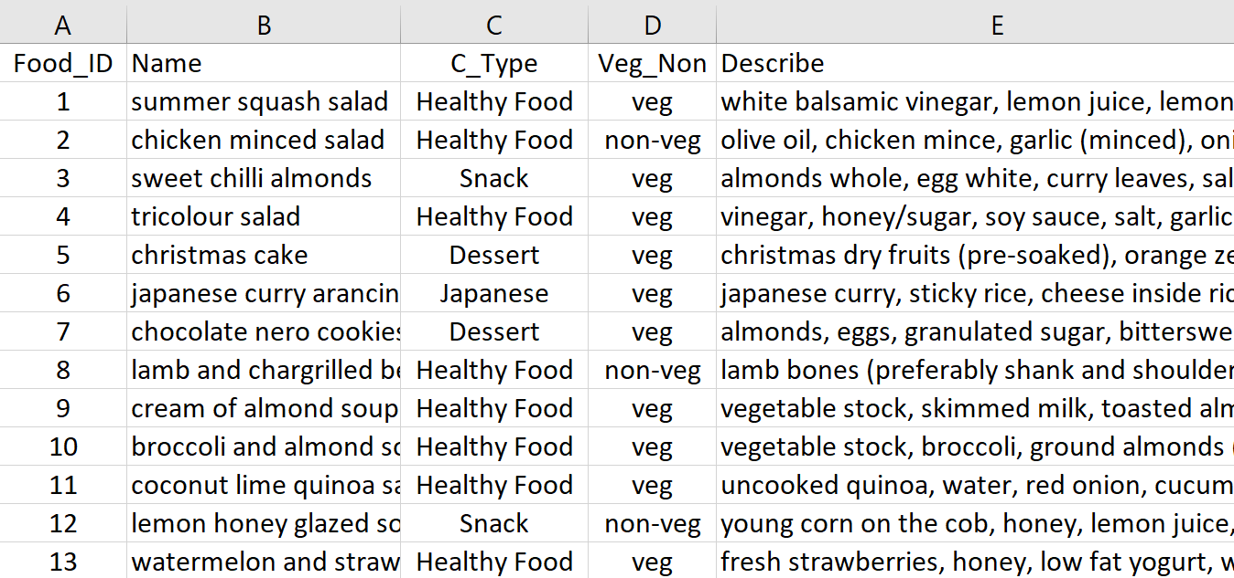

Fig. 1. Food Recommendation Dataset

These columns collectively provide a comprehensive representation of each food item in your dataset. The recommendation system leverages the textual information in the 'Describe' column to generate embeddings using Roberta and, based on these embeddings, suggests similar food items. It is essential to remember that the quality and applicability of the data in the 'Describe' column may have an impact on how effective the recommendation system is. Additionally, you can explore further enhancements, such as incorporating user preferences, incorporating additional features, or using more advanced models for improved recommendations.

4.2 Methodology

The food recommendation system methodology begins with the acquisition of a dataset containing essential information about various food items. This dataset includes columns such as 'Food_Id', 'Name', 'C_type', 'Veg_Non', and 'Describe'. Each row in the dataset represents a distinct food item, with details ranging from identifiers and names to categorical information about cuisine type and vegetarian or non-vegetarian status, along with a textual description providing additional context about the dish. The initial step of pre-processing involves handling missing values to maintain data integrity. Subsequently, an exploratory data analysis (EDA) is conducted to understand the distribution of data, identify outliers, and determine if further pre-processing steps are required to ensure the dataset's quality. Visualization plays a crucial role in gaining insights into the dataset. Various plots such as count plots, point plots, heatmaps, pie charts, and crosstab plots are employed. These visualizations provide a comprehensive understanding of the distribution of categorical variables, relationships between features, correlations among numerical attributes, and the proportion of vegetarian and non-vegetarian items. Following visualization, the dataset is split into training and testing sets using a train-test split, typically allocating 80% for training and 20% for testing. This ensures the ability to evaluate the model's performance on unseen data.

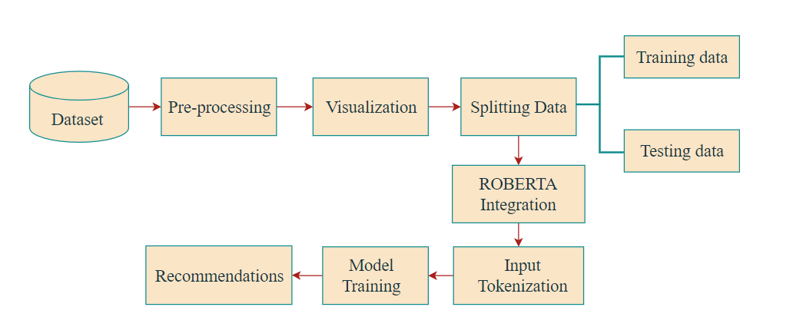

Fig. 2. Proposed model diagram

The integration of Roberta into the recommendation system involves tokenizing the textual descriptions using the Roberta tokenizer and extracting embeddings from the Roberta model. This step captures the semantic information embedded within the textual descriptions, which is crucial for understanding the inherent relationships between different food items. Model training revolves around calculating cosine similarity between the embeddings of the training and testing data. One metric to assess how similar two non-zero vectors are in an inner product space is cosine similarity. In the context of a recommendation system using Roberta embeddings, cosine similarity is employed to quantify the similarity between the embeddings of different food items. Here is a more detailed explanation of how cosine similarity is utilized in the methodology: After extracting embeddings from the Roberta model for both the training and testing data, the next step involves calculating the cosine similarity between these embeddings.

# Results

The embeddings are essentially vectors in a high-dimensional space, where each dimension corresponds to a feature capturing the semantic representation of the food items. The cosine similarity matrix is calculated by comparing each testing item's embedding with all training item embeddings.

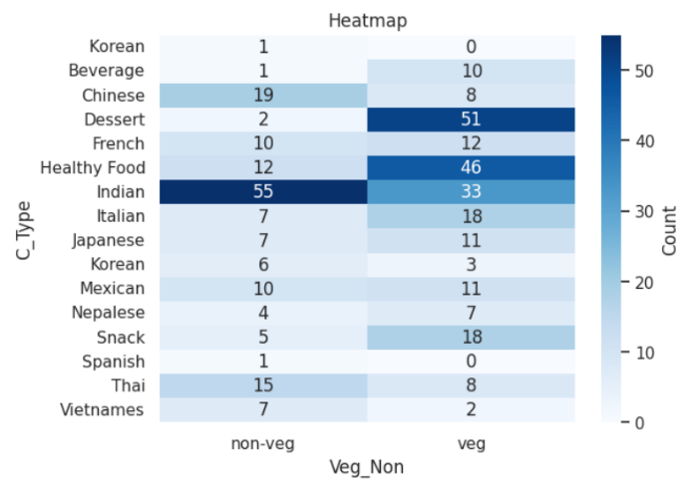

Fig. 3. Plotting Heatmap for C_Type and Veg_Non Columns

The resulting matrix provides a comprehensive measure of similarity between each testing item and all training items. The higher the cosine similarity score, the more similar the items are in terms of their semantic content. Once the cosine similarity matrix is computed, the recommendation system can identify the top N food items with the highest cosine similarity scores for each testing item. These top N items are then considered as recommendations for the user.

At first, we will recommend top n items in the test data and then we will predict the food recommendations which are unknown to the model with test dataset. Using the recommend_top_N_items function, the ml model successfully generates top-N recommendations for each individual food item in the test set. For example, given a specific test item index, the function computes cosine similarity scores between the embedding of that item and all other training items. The top-N items with the highest similarity scores are then presented as recommendations. The results demonstrate the system's proficiency in capturing semantic relationships and identifying similar food items.

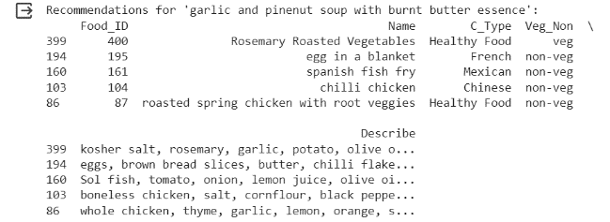

Fig. 4. Food Recommendations for ‘garlic and pinenut soup with burnt butter essence’

After that, the predict recommendation’s function extends the recommendation process to multiple test items. For a predefined set of test item indices, the system predicts and prints recommendations for each item. This functionality mimics real-world scenarios where users might seek suggestions for multiple items simultaneously. The printed recommendations provide a clear and user-friendly presentation of the suggested food items, enhancing the system's usability.

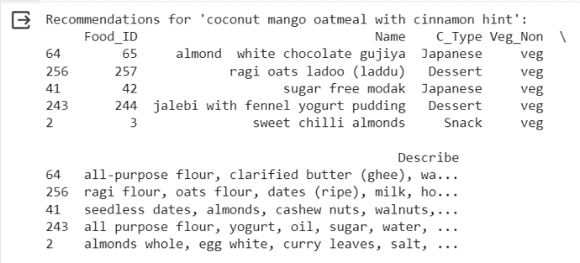

Fig. 5. Food Recommendations for Coconut mango oatmeal with cinnamon hint

The underlying strength of RoBERTa embeddings and cosine similarity becomes evident in the diverse and contextually relevant recommendations. The system's ability to capture intricate semantic relationships within food descriptions ensures that the suggestions align closely with the user's preferences. This robust understanding of the content enriches the recommendation process, distinguishing it from more conventional approaches. The results collectively highlight the real-world applicability of the recommendation system. Whether a user seeks suggestions for a single item or multiple items, the system consistently delivers tailored and coherent recommendations. This adaptability positions the system as a versatile tool, capable of catering to the dynamic and evolving preferences of users in diverse culinary scenarios.

# VI. Conclusion

The journey to develop a sophisticated food recommendation system centered around Roberta embeddings and cosine similarity has illuminated a promising pathway to deliver personalized culinary suggestions. The methodology commenced with meticulous dataset preparation, focusing on integrity and exploration through insightful visualizations. Roberta’s integration provided a means to extract nuanced semantic information from food descriptions, while cosine similarity emerged as a potent metric to quantify the closeness between these semantic representations. Cosine similarity's effectiveness lies in its ability to discern the angle between vectors, offering a metric that captures the subtleties of semantic relationships. By computing cosine similarity scores between the training and testing data, the system lays the groundwork for generating recommendations. The resulting cosine similarity matrix becomes a pivotal tool, allowing the identification of top recommendations for each testing item, ultimately delivering tailored and pertinent suggestions to end-users. The diverse set of visualization techniques, including count plots, point plots, heatmaps, pie charts, and crosstab plots, played a crucial role in comprehending dataset characteristics and guiding decision-making throughout the development process. The strategic train-test split ensured an unbiased evaluation of the model's performance on unseen data, contributing to the system's reliability. This methodology underscores the significance of continuous refinement, tailoring the approach to specific dataset nuances and user preferences. While Roberta embeddings and cosine similarity offer a strong foundation, the pursuit of excellence involves considerations of user feedback, exploration of alternative models, and the fine-tuning of parameters. This adaptability is crucial to enhance the system's accuracy and responsiveness to evolving user tastes and dataset dynamics. In summary, the food recommendation system, enriched by advanced natural language processing techniques, not only demonstrates the potential to curate personalized culinary experiences but also highlights the importance of ongoing evaluation, user engagement, and a willingness to explore cutting-edge methodologies. The system stands as a testament to the intersection of technology and gastronomy, promising a delightful journey for users seeking tailored and enticing food recommendations.

REFERENCES

[1]. M. Rostami, V. Farrahi, S. Ahmadian, S.M.J. Jalali, and M.Oussalah, "A novel healthy and time-aware food recommender system using attributed community detection," Expert Systems with Applications, vol. 221, p. 119719, 2023.

[2]. M. Rostami, U. Muhammad, S. Forouzandeh, K. Berahmand, V. Farrahi, and M. Oussalah, "An effective explainable food recommendation using deep image clustering and community detection," Intelligent Systems with Applications, vol. 16, p. 200157, 2022.

[3]. G. Sekhar Babu, V. Ramya, K. Charishma Sai Lakshmi, M. P. V. Sai Kumar Reddy, G. Bala Nagendra, and R. V. V. Satyanarayana Murthy, "Food Recommender-System Using Machine Learning and Graph Clustering," International Research Journal of Engineering and Technology (IRJET), vol. 10, Special Issue, Apr. 2023.

[4]. A. Ajami and B. Teimourpour, "A Food Recommender System in Academic Environments Based on Machine Learning Models," arXiv:2306.16528, Jun. 2023. https://doi.org/10.48550/arXiv.2306.16528.

[5]. R. M. Gomathi, P. Ajitha, G. H. S. Krishna and I. H. Pranay, "Restaurant Recommendation System for User Preference and Services Based on Rating and Amenities," 2019 International Conference on Computational Intelligence in Data Science (ICCIDS), Chennai, India, 2019, pp. 1-6, doi: 10.1109/ICCIDS.2019.8862048.

[6]. Naik, Pratiksha. (2020). Intelligent Food Recommendation System Using Machine Learning. International Journal of Innovative Science and Research Technology. 5. 616-619. 10.38124/IJISRT20AUG414.

[7]. Singh, Reetu & Dwivedi, Pragya. (2023). Food Recommendation Systems Based on Content-based and Collaborative Filtering Techniques. 10.1109/ICCCNT56998.2023.10307080.

[8]. Pritee, Auckloo & Ojha, Sanjay & Sinha, Lata & Bhardwaj, Somiya & Gupta, Nitish & Chawla, Tarun & Samadhiya, Arpit. (2023). Food Recommendation System Based on Mood of the User. 10.1007/978-981-99-3963-3_45.

[9].Gopalakrishnan, Anilkumar. (2021). A Food Recommendation System Based on BMI, BMR, k-NN Algorithm, and a BPNN. 10.1007/978-981-15-7106-0_11.

[10]. Ng, Yiu-kai & Jin, Meilan. (2017). Personalized Recipe Recommendations for Toddlers Based on Nutrient Intake and Food Preferences. 243-250. 10.1145/3167020.3167057.

[11]. Lakshmi, N. & Reddy, M. & Krishna, K. & Reddy, S.. (2022). Vitamin Deficiency and Food Recommendation System Using Machine Learning. International Journal for Research in Applied Science and Engineering Technology. 10. 3823-3830. 10.22214/ijraset.2022.43236.

[12]. Chen, Yi & Guo, Yandi & Fan, Qiuxu & Zhang, Qinghui & Dong, Yu. (2023). Health-Aware Food Recommendation Based on Knowledge Graph and Multi-Task Learning. Foods. 12. 2079. 10.3390/foods12102079.

[13]. P K, Manoj & C K, Saritha & Lakshmi, & Khadanga, Manasi. (2023). FEEDBACK BASED FOOD RECOMMENDATION SYSTEM USING HYBRID DEEP LEARNING. Bandaoti Guangdian/Semiconductor Optoelectronics. 42. 170-176.

[14]. Jain, Anjali & Singhal, Alka. (2022). Personalized Food Recommendation—State of Art and Review. 10.1007/978-981-16-7952-0_15.

[15]. Gao, Xiaooyan & Feng, Fuli & Huang, Heyan & Mao, Xian-Ling & Lan, Tian & Chi, Zewen. (2021). Food Recommendation with Graph Convolutional Network. Information Sciences. 584. 10.1016/j.ins.2021.10.040.